Name: Anuj Parihar  
Reg No: 21BBS0162  
Course: Programming in Python CBS1011

Q1 Write a program to print the multiplication table from 2 to n upto 10th term.

Code:

# Name: Anuj Parihar

# RegNo: 21BBS0162

n = int(input("Enter the number: "))

# list = [n*i for i in range(1, 11)]

#

# if using list comprehension, the above code can be used instead of the below code:

list = []

for i in range(1,11):

    list.append(n*i)

print(list)

Output:

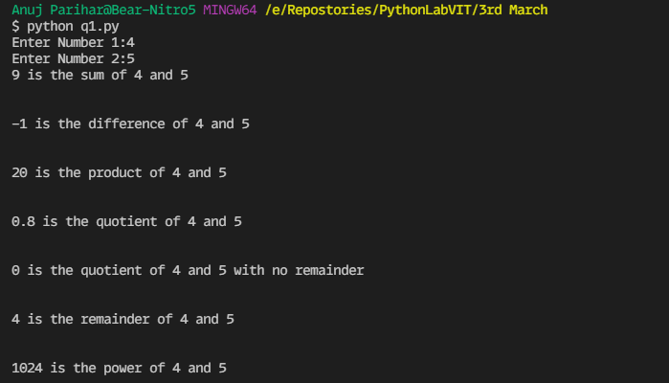

Q2. Write a program to modify all elements in a list using list comprehension [Note: If the number is odd then compute Cube else compute square

Code:

# Name: Anuj Parihar

# RegNo: 21BBS0162

list = [1, 2, 3, 4, 5, 6, 7, 8, 9, 10]

list = [i**3 if i%2 else i**2 for i in list]

print(list)

Output:

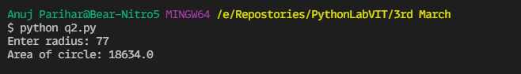

Q3 Write a program to print the sum of all elements in a list

Code:

# Name: Anuj Parihar

# RegNo: 21BBS0162

list = [1, 2, 3, 4, 5, 6, 7, 8, 9, 10]

sum = 0

for i in list:

    sum += i

print(sum)

Output:  
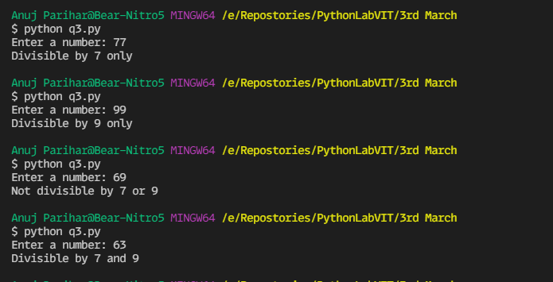

Q4. Write a program to sortthe elementsin ascending order.

Code:

# Name: Anuj Parihar

# RegNo: 21BBS0162

list = [59,894,20,25,1]

for i in range(len(list)):

    for j in range(i+1,len(list)):

        if list[i] > list[j]:

            list[i],list[j] = list[j],list[i]

print(list)

Output:

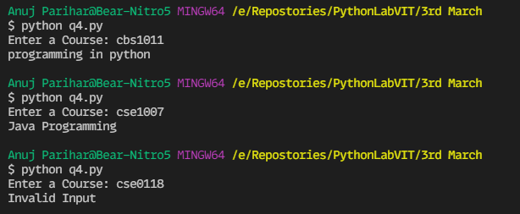

Q5. Write a program to perform the matrix addition and matrix multiplication

Code:

# Name: Anuj Parihar

# RegNo: 21BBS0162

# matrix addition

A = [[1,2,3],[4,5,6],[7,8,9]]

B = [[1,2,3],[4,5,6],[7,8,9]]

for i in range(len(A)):

    for j in range(len(A[0])):

        A[i][j] += B[i][j]

print(A)

# matrix multiplication

A = [[1,2,3],[4,5,6],[7,8,9]]

B = [[1,2,3],[4,5,6],[7,8,9]]

result = [[0,0,0],[0,0,0],[0,0,0]]

for i in range(len(A)):

    for j in range(len(B[0])):

        for k in range(len(B)):

            result[i][j] += A[i][k] * B[k][j]

print(result)

Screenshots:

